PISMO MEDICAL CAMPUS
SPACE AVAILABLE FOR LEASE
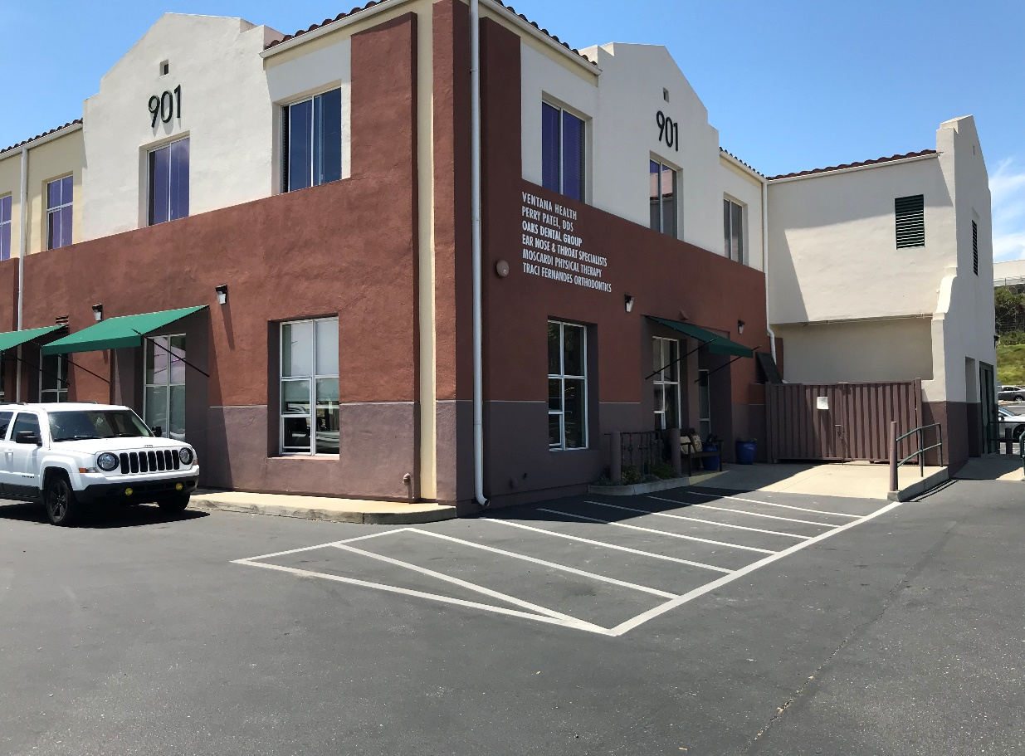

1,907 SF
650 SF

Address: 901 Oak Park Blvd., Suite 102
Pismo Beach, CA 93449
SF: 650
Rent: $2.50/SF plus NNN
Available: Immediately

Address: 901 Oak Park Blvd., Suite 103
Pismo Beach, CA 93449
SF: 1,907
Rent: $2.50/SF plus NNN
Available: July 1, 2021

Tim (Beau) Oxsen, Broker
Shaw Commercial
Office: (831) 772-8100 x120, Cell (831) 262-8749
Email: beau@shaw-development.com
CA DRE #01871028

